# UNIT 2

**Computer Architecture**



Picture 2.1

**Learning Outcomes**: By the end of the lesson, the students are expected to be able to use appropriate English to:

* identify and describe kinds of computer
* read a computer advertisement
* identify parts of computer
* describe functions of parts of computer
* identify comparatives and superlatives
* identify phrases used for presentation
* perform a presentation using phrases explained
* compare and contrast computers and any other devices using comparative and superlatives

# Reading a computer advertisement

**Exercise 1:** You are going to listen to an extract from an ICT class about **five** types of computer.

As you listen, identify the pictures (a-e) with words from the box.

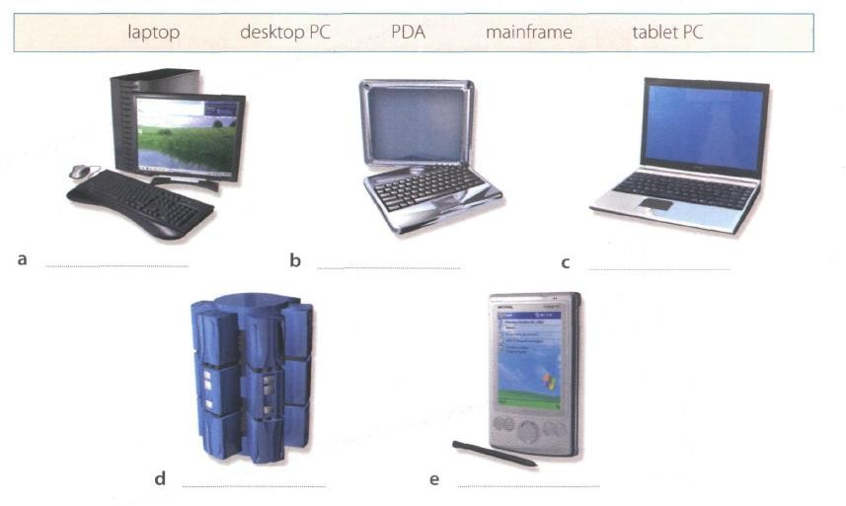

Picture 2.2

1. Desktop PC (keyword : classified by size and portability, desktop pc designed to place on desk, used as a home computer, or as a workstation for group work)
2. Tablet PC (keyword : type of notebook computer that has lcd screen which we can write with stylus/digtial pen, handwritting recognized and converted into editable text, can also use speech recognition or small keyboard, can fold and rotate the screen)
3. Laptop (keyword : portable computer, has a flat lcd screen, uses batteries for mobile use, small laptops called notebooks)
4. Mainframe (keyword : the largest and most powrful computer, which proccess immense amount of data very quickly, provides information and computing facilities for hundreds of terminal, used for large scale computing purposes in a big companies, banks, universities)
5. PDA/Personal Digital Assistant (keyword : lightweight handheld computer, for type we use the small keyboards or stylus, can use as a mobile phone, personal organizers or media players, we can also access the internet via wifi, and some include gps navigation)

**Exercise 2**: Listen again and decide whether these sentences are true or false. Correct the false ones.

* + 1. A mainframe computer is less powerful than a PC. (T/F)

False, because as it was mention before on the audio, mainframe are the largest and the most powerful computer, because it can proccess immense amount of data quickly, and it also use for a large scale of computing in a big company, banks, or university

* + 1. A mainframe is used by large organizations that need to process enormous amounts of data. (T/F)

True, because the central system provides information and computing facilities for hundreds of terminals connected together in a network to proccess a big amount of data, so it is suitable to used by large organizations

* + 1. The most suitable computers for home use are desktop PC. (T/F)

True, because it is designed to be placed on the desk and can be used as a home computer

* + 1. A laptop is not portable. (T/F)

False, because laptop is a portable computer and it also use batteries so it is more suitable for mobile use, it is very convinience and ideal for anyone who travel a lot

* + 1. Laptops are not as powerful as desktop PCs. (T/F)

False, because the latest models of laptops can run as fast as dekstop PCs, and have a similar configurations

* + 1. Using a stylus, you can write directly onto the screen of a tablet PC. (T/F)

True, because it has an LCD screen which we can write directly with a stylus, and out handwrite will recognize and convert into a editable text

* + 1. A Personal Digital Assistant is small enough to fit into the palm of your hand. (T/F)

True, because as it was mentioned on the audio, that the PDA term reffers to a wide variety of hand-held devices including palm tops and pocket pcs, so obviously it can fit into the palm of our hand

* + 1. A PDA does not allow you to surf the Web. (T/F)

False, because it can be used as a mobile phone, which let us access the internet via wifi networks, so that we can also open a web with a PDA

**Exercise 3**: Match these names to the different types of computer.

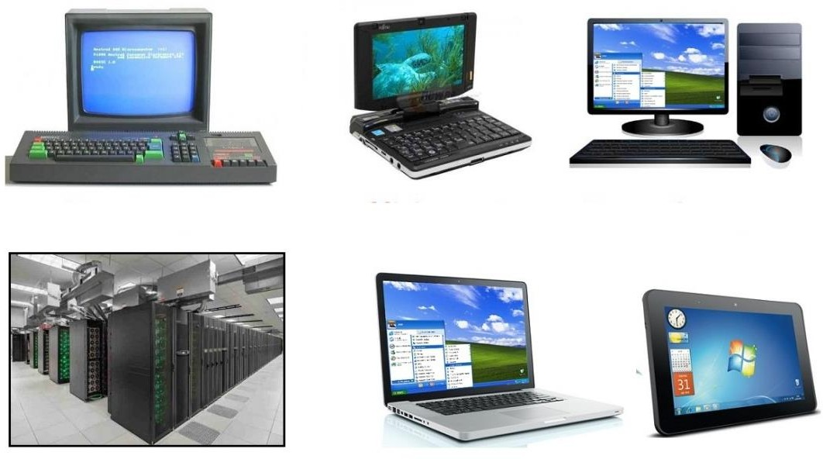

Picture 2.3

|  |  |  |
| --- | --- | --- |
| 1. minicomputer | 3. tablet | 5. PC |
| 2. laptop | 4. microcomputer | 6. supercomputer/mainframe |

**Exercise 4**: Listen to Part 1 of the conversation between a shop assistant and a customer. Tick

(√) the correct answers to the questions below.

1. The customer wants a computer for......
   * writing □ internet □ games
   * graphics □ video
2. A multimedia computer provides......
   * sound □ telephone
   * graphics □ video
   * games

**Exercise 5:** Listen to Part 2 of the conversation. In column A, tick hardware items named. In

column B, tick the items the assistant recommends.

|  |  |  |  |  |  |
| --- | --- | --- | --- | --- | --- |
| **A** | **B** | **Device** | **A** | **B** | **Device** |
| √ | □ | multimedia computer | □ | √ | handheld |
| □ | √ | multimedia notebook | □ | √ | printer |
| □ | √ | subnotebook | √ | □ | monitor |
| √ | □ | laptop | □ | √ | Modem |

**Exercise 6**: Study the text entitled ”How to Read a Computer Ad” and then answer the following

questions.

1. What is the memory size of PC?

16 GB dual channel DDR4 SDRAM

1. What storage devices are supplied?

512 SSD & 2TB of SATA HDD

1. What size is the display screen?

42” inch 4K resolution

1. How fast is the processor?

Base clock : 3.6 GHz, Bus Speed : 800 MHz

‘

1. What is the capacity of the hard drive?

2 TB

1. Which operating system does it use?

Microsoft Windows 10 Professional

1. What multimedia features does the computer have?

Integrated Dolby Atmos Stereo Audio

**HOW TO READ A COMPUTER AD.**

|  |  |
| --- | --- |
| 1. Intel Core i7-9700K 9th Generation (Coffee lake). Base Clock: 3.6 GHz, Bus Speed: 800 MHz 2. Mini-tower chassis 3. 16 GB dual channel DDR4 SDRAM 4. 512 SSD & 2 TB Serial ATA hard drive (7200 r.p.m) 5. 8 GB GDDR6 NVIDIA PCI-Express video graphic card 6. Integrated Dolby Atmos Stereo audio 7. Corsair K95 RGB Platinum Keyboard 8. 42” TFT flat panel 4K (3840 x 2160) monitor 9. Microsoft Windows 10 Professional | TowerPC  Picture 2.4 |

|  |  |  |
| --- | --- | --- |
| 1. The main processing chip called a ‘core i7’ that was designed and manufactured by the intel Corporation. It operates at a clock speed of three- point six gigahertz and has a front-side bus that operates at a speed of eight hundred megahertz. 2. A small, tall and narrow style of case containing the computer system. 3. Synchronous dynamic random-access memory with a capacity of sixteen gigabyte. It is a high bandwidth, double data rate memory. | 1. A Solid-state drive with a 512 gigabytes storage and a hard drive with a capacity of two terabytes that uses a type of connection interface known as Serial ATA. It has a serial data connection rather than the original parallel connection. It rotates at a speed of seven thousand, two hundred revolutions per minute. 2. Electronics for driving the graphics output that has a memory capacity of eight gigabytes and uses a type of connection interface known as PCI-Express. | 1. Electronics for controlling the sound output that is built into the main electronics of the computer. 2. The K95 Platinum is a big keyboard. Dedicated media controls and a USB pass-through, a metal volume wheel, RGB lighting. It even comes with an extra set of textured keycaps for the WASD keys. 3. A forty-two inch, flat display screen made from thin film transistors with a resolution of 3840 by 2160. 4. The operating system that is used to control the   system. |

*Oxford English for Information Technology (2011: 11)*

# Describing functions of computer

We can describe the function of an item in a number of ways. Study these examples.

|  |  |
| --- | --- |
| **Using the present simple**   1. ROM *holds* instruction which are needed to start up the computer.   ***Used to-*infinitive, *Used for + -ing***  **form**   1. ROM is *used* to *hold* instructions which are needed to start up the computer. | 1. ROM is *used for holding* instructions which are needed to start up the computer.   **Emphasizing the function**   1. *The function of ROM is* to hold instruction which are needed to start up the computer. |

**Exercise 7**: Match each item with its functions. Then describe the functions in three ways as the

examples on the table above.

|  |  |
| --- | --- |
| **Items** | **Functions** |
| 1. RAM (H) 2. Processor (J) 3. Mouse (A) 4. Clock (I) 5. flash memory key (E) 6. monitor (C) 7. keyboard (B) 8. cache (G) 9. DVD-ROM drive (D) 10. ROM (F) | 1. controls the cursor 2. inputs data through keys like a typewriter 3. displays the output from a computer on a screen 4. reads DVD-ROMs 5. reads and writes to electronic chips on a card 6. holds instructions which are needed to start up the computer 7. holds data read or written to it by the processor 8. provides extremely fast access for sections of a program and its data 9. controls the timing of signals in the computer 10. controls all the operations in a   computer |

**Exercise 8**: With your partner, describe the functions of these items using the forms you have

learned before.

* + 1. Scanner

(a scanner is a device with the function to scan or take picture of the documents)

* + 1. Printer

(a unit attached to a computer that produces text on paper/hard copy of a document); PERIPHERAL DEVICE

* + 1. CPU

(the brains of the computer, processes data and controls the flow of data between the computer’s other units; INTERNAL OPERATING UNIT)

* + 1. SSD

(a storage device containing nonvolatile flash memory, used in place of a hard disk because of its much greater speed)

* + 1. hard disk driver

(hard disk drives control the reading and writing of the hard disk that provides data storage)

* + 1. ports

(the main function of the ports is to transfer data from external or internal device to the user’s PC or laptop)

* + 1. mainframe computer

(mainframe computers are mainly used to handle large organizational data for critical apllications, such as big data processing, census, industrial and consumer statistics, to transaction processing)

* + 1. barcodes

(barcodes serves to store complete information about an item or product that has a barcode label)

* + 1. swipe cards

(plastic card such as a credit card or ID card bearinig magnetically encoded information which is read when the edge of the card is slid through an electronic device)

* + 1. main memory

(the function of main memory is to store data to be processed and programs to be run by the computer).

# Comparing and contrasting computer

**Exercise 9:** Study these details of different types of computers. Find answers to the questions.

Which computer is?

* + 1. The most common? Laptop
    2. Small enough for a pocket? Subnotebook
    3. The most common portable? Notebook
    4. Used by many people at the same time? Mainframes
    5. Used like mainframes? Minicomputer
    6. Also called a handheld computer? Palmtop
    7. The most powerful? Mainframes
    8. Not suitable for a lot typing?Palmtop

|  |  |
| --- | --- |
| **Types of Computer** | **Notes** |
| **Mainframes** | Large, powerful, expensive.  Multi-user systems – used by many people at the same time.  Used for processing very large amounts of data. The most powerful mainframes are called  *supercomputers.* |
| **Minicomputers** | Used like mainframes.  Not as big, powerful, or expensive as mainframes. Less common now because microcomputers have improved. |
| **Microcomputers or Personal**  **computers (PCs)** | The most common type of computer.  Smaller, cheaper, and less powerful than mainframes and minicomputers. |

|  |  |
| --- | --- |
| **Types of Portable** | **Notes** |
| **Laptop** | About the size of small typewriter.  Less common now because smaller and lighter portables are available. |
| **Notebook** | About the size of a piece of writing paper.  The most common type of portable. |
| **Subnotebook** | Not quite as big as notebooks. Can fit into a jacket pocket. |
| **Handheld or Palmtop** | Small enough to fit into the palm of one hand. Not easy to type with because of their size.  Specialized handheld computer known as PDAs are used as  personal organizers. |

**Exercise 10:** Study this comparison of three types of computer.

|  |  |  |  |
| --- | --- | --- | --- |
|  | **Mainframes** | **Minicomputers** | **Microcomputers** |
| **Size** | **+++** | **++** | **+** |
| **Power** | **+++** | **++** | **+** |
| **Cost** | **+++** | **++** | **+** |

We compare things using adjectives in two ways.

1. We can compare one type of computer with another.

*Minicomputers are* ***bigger than*** *microcomputers. Mainframes are* ***more expensive than*** *microcomputers.* For negative comparisons, we can say:

*Microcomputers are* ***not as big as*** *minicomputers. Microcomputers are* ***not as powerful as*** *mainframes.*

1. We can compare mainframes to all other types of computer.

*Mainframes are* ***the biggest*** *computers. Mainframes are* ***the most powerful*** *computers. Mainframes are* ***the most expensive*** *computers.*

With short adjectives (big*, small, fast*), we add *–er* and *–est* (*faster, fastest*). With longer adjectives (*powerful, expensive*), we use *more/less* and the *most/ the least* before the adjectives (*more powerful, the most powerful)*.

Remember some exceptions:

*good – better – the best bad – worse – the worst*

**Exercise 11:** Choose the correct adjectives. Then fill in the gaps with the correct form of the

adjectives.

|  |  |
| --- | --- |
| ***light/heavy***  ***large/small***  ***common/good***  ***powerful/expensive***  ***fast/cheap***  ***powerful/expensive*** | Laptops are **1  Lighter** than desktop computers, but  **2 heavier** than notebooks.  The mainframes is the **3 largest** type of computer. A minicomputer is **4 smaller** than a microcomputer.  Personal computer are **5 commoner/more common** than mainframes but mainframes are **6 better** than personal computers at processing very large amounts of data.  Minicomputers are **7 less powerful** than mainframes but they are also **8  less expensive**  New computers are **9 faster** and sometimes  **10 _____cheaper___**than older machines.  Laptops are often 11 l ____**less powerful**____than PCs but they are not as **12 expensive** |

**Exercise 12**: Put the words in brackets into the correct form.

There are different types of computer. The (*large*) **1 largest** and (powerful)

**2 the most powerful** are mainframe computers. Minicomputers are (small)

**3 smaller** than mainframes but are still very powerful. Microcomputers are small enough to sit on a desk. They are the (common) **4 most common** type of computer. They are usually (powerful) **5 more powerful** than microcomputers.

Portable computers are (small) **6 smaller** than desktops. The (large)

**7 largest computer** portable is a laptop. (Small) **8 smallest computer** portables, about the size of a piece of writing paper, are called notebook computers. Subnotebooks are (small)

**9 smaller** than notebooks. You can hold the (small) **10  smallest**

computers in one hand. They are called handheld computers or palmtop computers.

**Exercise 13**: In pairs, discuss who or what you think is:

1. The most difficult game you’ve ever played.
2. The most exciting film you’ve ever seen.
3. The funniest program on TV.
4. The most dangerous computer virus.
5. The best blogger or webmaster on the web.
6. The most popular web browser.

**Exercise 14**: Preparation is essential for an effective presentation. Here are some phrases that

can help you delivering a better presentation.

# Useful Phrases for Presentation

When giving a presentation, certain keywords are used to signpost the different stages. It’s a good idea to memories them and practice them so that they come to your mind easily during a presentation.

|  |  |
| --- | --- |
| **Useful Phrases for Presentation** | |
| **Starting the presentation** | **Explaining the purpose** |
| * Good morning/good afternoon ladies and gentlemen. * The subject of my presentation today is … * What I’m going to talk about today is … | * The purpose of this presentation is … * My objective is to … * My main aim today is to … |
| **Stating the main points** | **Introducing the first point** |
| * The main points I will be talking about   today are firstly …, secondly …., next …., finally, we’re going to look at… | * Let’s start/begin with … * I’d like to start by …. |
| **Showing visuals** | **Moving on to the next point** |
| * I’d like to illustrate this by showing you … | * Now let’s move on to … |
| **Referring to an earlier point** | **Summarizing** |
| * Let me go back to what I said earlier about   … | * I’d like to recap the main points of my presentation. First I covered …, then we   talked about … and finally we looked at …   * I’d now like to sum up the main points, which were … |

|  |  |
| --- | --- |
| **Conclusion Inviting** | **Questions** |
| * I’m going to conclude by … saying that / inviting you to / quoting … * In conclusion, let me leave you with this   thought / invite you to … | * Finally, I’ll be happy to answer your   questions.   * Now I’d like to invite any questions you   might have.   * Do you have any questions? |

**Exercise 15**: Now put the following phrases in the correct groups. Add some more phrases that

you know.

* In conclusion, let me leave you with this thought / invite you to conclusion
* Good morning/good afternoon ladies and gentlemen starting the presentation starting the presentation
* The main points I will be talking about today are firstly …, secondly …., next …., finally, we’re going to look at starting the main point
* I’m going to conclude by … saying that / inviting you to / quoting conclusion
* Now let’s move on to moving on to the next point
* My objective is to explaining the purpose
* Finally, I’ll be happy to answer your questions inviting questions
* Now I’d like to invite any questions you might have inviting questions
* What I’m going to talk about today is starting the prestation
* The subject of my presentation today is starting the presentation
* I’d like to illustrate this by showing you showing visuals
* I’d like to recap the main points of my presentation. First I covered …, then we talked about

… and finally we looked at summarizing

|  |  |
| --- | --- |
| Useful Phrases for Presentation | |
| **Starting the presentation** | **Explaining the purpose** |
|  |  |
| **Stating the main points** | **Introducing the first point** |
|  |  |
| **Showing visuals** | **Moving on to the next point** |
|  |  |
| **Referring to an earlier point** | **Summarizing** |
|  |  |
| **Conclusion** | **Inviting Questions** |
|  |  |

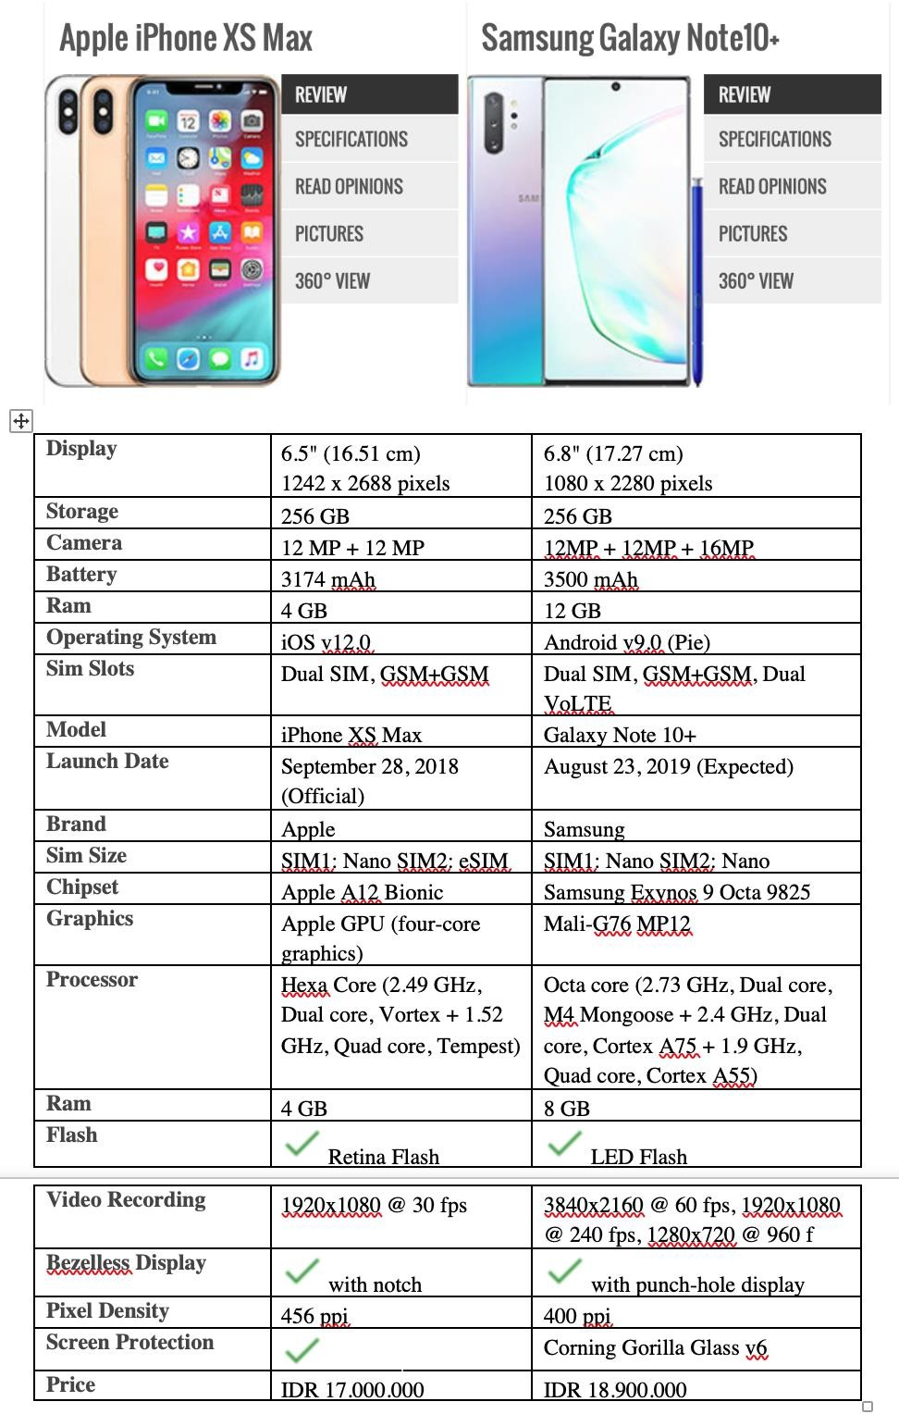

Picture 2.5

**Exercise 16**: In pairs, find two different advertisements of PCs/laptops/any gadgets and write some comparisons (at least 10 sentences) based on their specifications and present it in the class. Use the phrases that you have learned today.

# Look at the example below.

**Example of Writing a Comparison between Two Things**

1. Samsung Galaxy Note 10+’s size is bigger than iPhone XS Max’s.
2. The storage of Samsung Galaxy Note 10+ and iPhone XS Max has the same capacity.
3. The price of Samsung Galaxy Note 10+ is more expensive than iPhone XS Max.
4. The samsung galaxy note 10+’s battery capacity is bigger than iphone xs max
5. The size ram of iphone is smaller than samsung
6. The pixel density of iphone is bigger than samsung